EDA Report on Interbank Call Rate

The Provided cleaned dataset describes the Interbank Call Rate between banks during the years of 2006 to 2024.

Data Information:

* Row Information: 220 Rows
* Column Information: 12 Columns

Data Context:

**Interbank rates** are the exchange rates used by banks and large financial institutions for large transactions; also known as the mid-market rate, spot rate, or real exchange rate, refer to the exchange rate used by banks and large financial institutions when trading large volumes of foreign currency with each other.

Our objective will be to better understand the interbank call rate in correlation to the price surge in the Nigerian Economy. There are additional factors that lead to our better understanding of the **interbank call rate**, such as the **Monthly Payment Rate(MPR**), **Deposits (1,3,6,12 Months)**, **Prime Lending Rates**, and **Max Lending Rates**.

**Monthly payment rate (MPR)** is the amount of money an individual or entity pays each month to service a loan/debt. **Prime Lending Rate** is the interest rate that commercial banks charge their most creditworthy customers for short-term loans. **Max Lending Rate** is the maximum interest rate that a lender can charge on a given loan/debt.

Central bank policies, Economic indicators, Creditworthiness of Borrowers and Reserve Requirements factor towards Interbank Call Rates between banks and ultimately goes in tandem with the willingness of banks to tank on risks.

Statistical Breakdown of Columns within Dataset:

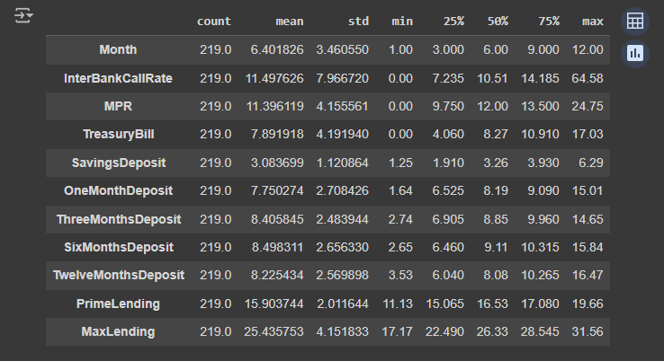

As we can see, the average Interbank Call Rate is 11.5% across the entire date range within the dataset (2006-2024).

The median Interbank Call Rate is 10.5%.

The highest Interbank Call Rate within our dataset appears to be 64.58%.

Histogram Observations:

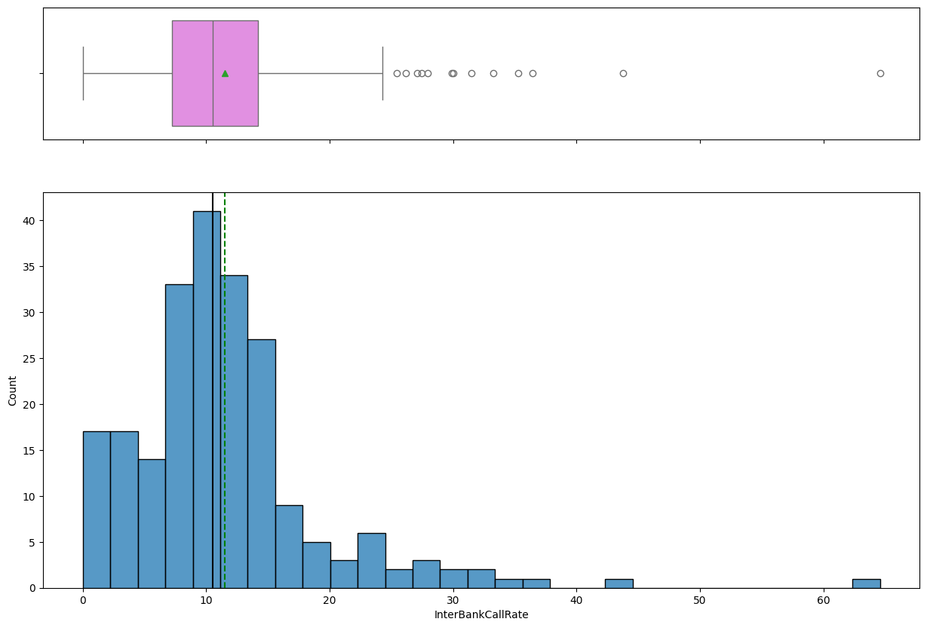

* An indicator of the Mean being larger than the median displays the right skewed distribution.
* There are more extreme outliers such as the 64.58%
* The highest frequency appears to be around 10%
* There are also some gaps, which could be factored by the government to encourage banks to allow borrowing, lowering risks for banks.

Time Series for Interbank Call Rate:

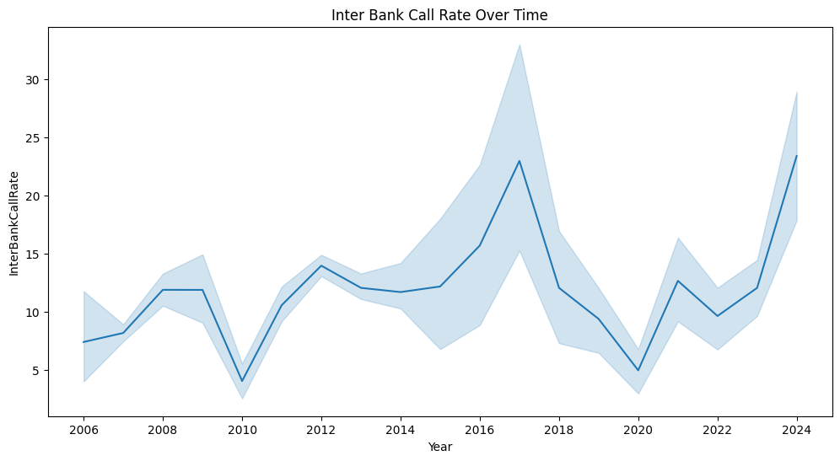

Correlation Matrix For Interbank Call Rate

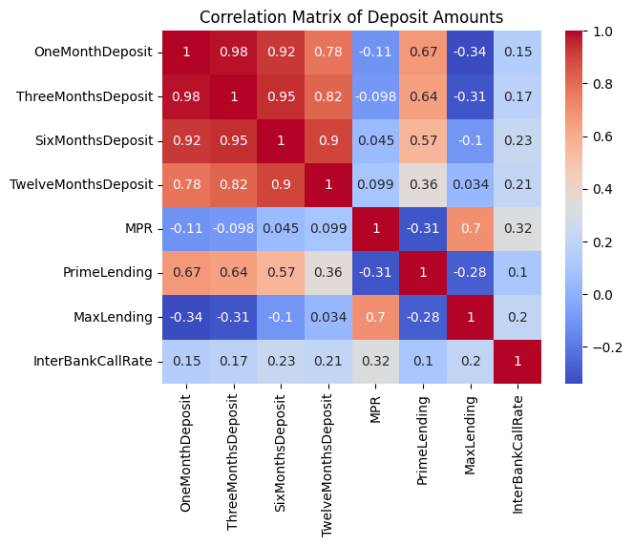

Based off the correlation matrix, Interbank Call Rate is affected mainly by the deposits and the MPR. There has been fluctuations over the years in Interbank Call Rate but currently within 2024, it is currently under 24%. The Interbank Call rate has been gradually increasing since 2020.